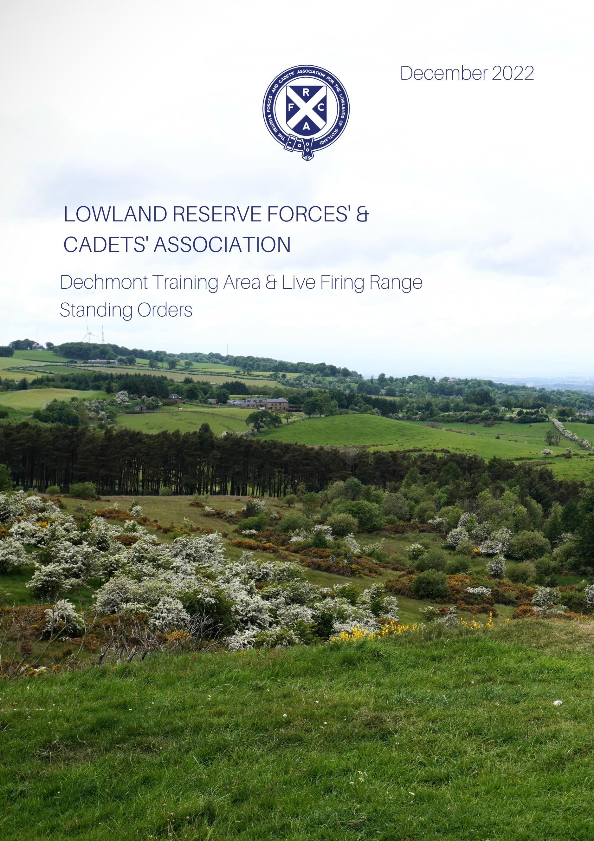
Record of Amendments
CHANGE NUMBER | DATE OF CHANGE | CHANGED BY | REMARKS

Table of Contents
Chapter 1 5
Dechmont Training Area RSOs General Information 5
Annexes: 16
Annex H to Dechmont Range Standing orders 29
Chapter 2 2-1
RANGE STANDING ORDERS (RSOs) FOR THE 25M BARRACK RANGE 2-1
Chapter 3 3-1
DECHMONT TRAINING AREA CLAY PIGEON RANGE - STANDING ORDERS 3-1
Chapter 4 4-1
DECHMONT TRAINING AREA ARCHERY RANGE - STANDING ORDERS 4-1
Chapter 5 5-1
CHAPTER RESERVED FOR OFF ROAD DRIVING 5-1
Chapter 6 6-1
NAVIGATION TRAINING/ORIENTEERING 6-1

INDEX
Chapter 1 RSO - General Instruction
Annex A. Dechmont Training Area in General Map
Annex B. Health & Safety at Work Category 2 Brief, (Contractors & Visitors)
Annex C. Accident / Incident Immediate Action and Reporting Procedure & Aide-Memoire
Annex D. Medical Emergency Immediate Action Procedure & Aide-Memoire
Annex E. Scottish Gas Network (SGN) Maps and Information
Annex F. Radiation Safety
Annex G. LRFCA Dechmont Training Area Booking Form
Annex H. Lyme Disease & Leptospirosis Information
Chapter 2 25m NDA Barrack Range
Chapter 3 Clay Pigeon Range
Chapter 4 Archery Range
Chapter 5 Off-Road Driving
Chapter 6 Navigation Training/Orienteering

Dechmont Training Area RSOs General Information
References:
A. Pamphlet No 21 Training Regulations for Armoured Fighting Vehicles, Infantry Weapon Systems and Pyrotechnics.
B. AC 71855-C Regulations for Cadet Weapon Systems and Pyrotechnics.
C. Operational Shooting Policy.
D. DSA 03. OME Part 3. Vol 1, Part 2.
E. Ordnance Survey Land Ranger Series Map Sheet 64 1:50000.
General:
1. These orders are provided to ensure that the Dry Training Area (DTA)/Range is used and maintained to the highest standards of safety and in accordance with currently approved regulations and procedures.
2. A copy of these orders must be permanently and prominently displayed at Range Control. They are to be read and complied with by all DTA and Range users and safety staff. Exercise Conducting Officers (ECOs) and Range Conducting Officers (RCOs), both military and civilian, are to be fully conversant with and must strictly comply with the contents of these orders.
The Range/Training Area
Ser  (a) | Subject  (b) | Details  (c)
1. | Name | Lowland Reserve Forces’ and Cadets’ Association (Lowland RFCA) Dechmont Training Area and Live Firing Range.
2. | DRSC Serial Number | N/A
3. | Description | 1. Lowland Reserve Forces’ and Cadets’ Association Dechmont Training Area and Live Firing Ranges lie to the southeast of Cambuslang, approx. 8 miles southeast of the city centre of Glasgow, Range Control is centred on OS Grid Ref: NS 65347 58570.  2. The area covers approximately 627 acres of grassland and small forestry blocks.  3. The Training Area has been used regularly by Regular Forces, Reserve Forces, Cadets and emergency services since at least the 1880s and now consists of six designated Dry Training Areas (DTAs) and a 6 Lane 25m NDA Barrack Range.  4. Training opportunities and facilities available are described in Ser 7.
4. | Location & Map Details | Lowland RFCA Dechmont Training Area  Gilbertfield Rd  Cambuslang  G72 8YP  Range Control OS Grid Ref: NS 65347 58570  Map Series Sheet 64 scale 1:50 000.
5. | Air Danger Area Identification and Height | N/A
6. | MOD FORM 905 (Range License) | MOD Form 905 for the 25m Barrack Range is displayed in Range Control and on the Range. DTA N/A
7. | Complex and Facilities | 1. Dechmont Range and Training area covers an area of 627 acres. One third is currently used for training (including the 25m Barrack Range), while two thirds (including a working farm) are let to a farmer. Facilities available for users are:  a. 6 Lane 25m NDA Barrack Range  b. Clay Pigeon Range  c. Archery Range  d. DTAs A, B, C, D, E & F, all suitable for low level Fieldcraft and Navigation lessons.  e. Area A - Currently leased and in use by local farmers.  f. Area B - Currently leased and in use by local farmers.  g. Area C - Expanse of low-lying grass land, suitable for all types of Dry Training.  h. Area D - Live Firing & DTA D incorporates the Clay Pigeon and Archery Range. Area D can be used for dry training when live firing or Archery is not taking place.  i. Area E - Incorporates the high ground of Dechmont hill (183m). This area is ideal for map reading, Observation Posts (OPs) or unit TEWTs.  j. Area F - Live Firing 6 Lane 25m NDA Barrack Range with surrounding grassland and wooded areas suitable for dry training and concurrent activity while the range is in use.  k. Range Control Compound – Offers users the following facilities:  (1) Classroom  (2) Toilet facilities  (3) Two outbuildings (useful for unit stores)  (4) Hard standing for parking  2. Although not part of the training area booking process, the nearby Glasgow and Lanarkshire Army Cadet Force (ACF) Dechmont Cadet Training Centre (CTC) has accommodation that can be requested. The Range Manager can advise on the contact details during the booking process.
8. | Public Access | All DTAs are used by the public under the Scottish Outdoor Access Code (SOAC) for walking, cycling and horse riding. Grazing rights have been granted to local farmers. Considerations of these factors are key to successful planning. Current information on how this may affect training can be discussed with the Range Manager during unit recces and planning.
WEAPONS AND AMMUNITION
YOU ARE RESPONSIBLE FOR SAFE PLACE,
SAFE PRACTICE, SAFE EQUIPMENT AND SAFE PERSON!
9. | Weapons | 1. All in-service weapons are permitted provided that the safe system of training is in place. All use is to be conducted in accordance with the relevant authoritative documents as per References A-D.  2. In-service weapons must employ a Blank Firing Attachment (BFA) with an applied danger area.
10. | Ammunition | 1. All in-service blank ammunition is permitted providing that the safe system of training is in place and all use is conducted in accordance with the relevant authoritative documents as per Reference A-D.  2. Regardless of whether live ammunition has been used previously or not, whenever blank ammunition is used there is always a danger that live ammunition could be introduced. To prevent this from happening the Exercise Conducting Officer (ECO) is to ensure that the following procedures are formally carried out in the sequence below:  a. If ammunition is issued in any form other than in factory sealed containers, the ECO is to ensure that a thorough physical check is carried out to ascertain that only blank ammunition is contained within. This includes:  (1) Ammunition issued in reconditioned, re-sealed containers. Confirmation that containers are factory sealed or reconditioned and re-sealed must be sought from issuing personnel.  (2) The condition of ammunition issued in unsealed containers must be regarded as unknown and the ECO is to ensure that it is thoroughly checked by the exercise staff before being issued.  b. As part of Normal Safety Precautions (NSPs), a thorough physical check of weapon chambers, ammunition, magazines, ammunition pouches, pockets, and other personal clothing and equipment is to be conducted.  c. A declaration must be taken from all exercising troops, stating that they do not have any live ammunition in their possession.  d. A reminder is given to all troops that they are responsible for ensuring that they load only blank ammunition in their magazines.  e. The Army Form B (AFB) 159B is to be signed by the ECO.  f. All troops are to be reminded if any ammunition or pyrotechnics are found after they have given the declaration, these are to be handed to a member of staff.  3. ECOs and Exercise Assistants are to ensure that BFAs are correctly fitted prior to the start of training.  4. For Live Firing Area see the relevant RSOs.
11. | Pyrotechnics | 1. All in-service pyrotechnics are permitted, provided that the safe system of training is in place and all use is to be conducted in accordance with the relevant authoritative documents as per Reference A-D. Due to the close proximity of civilian housing, the following caveats are specific to Dechmont:  a. Units are to ensure that safety distances are applied at all times, noting that members of the public are able to access the training area.  b. No pyrotechnics are to be used with 200m of the training area boundary unless authorised by the Range Manager.  c. 1.5-inch Rocket Flares/Rockets Hand Fired. If the wind strength/direction is such that there is a risk of flares drifting off the training area, they MUST not be used.  d. The Pistol Signal 16 mm Mini-flare. No red or orange flares are to be used as this would notify local emergency services of a distress signal.  e. Smoke Generator. No red or orange. If the wind strength/direction is such that there is a risk of smoke being blown over roads/populated areas, they MUST not be used.
12. | Battlefield Simulations | All Battlefield Simulation must be annotated on Range Safety Documents (RSDs) and authorised by the Range Manager (RM).
DTA SAFETY LIMITATIONS
YOU ARE RESPONSIBLE FOR SAFE PLACE,
SAFE PRACTICE, SAFE EQUIPMENT & SAFE PERSON!
13. | Applied Danger Area, Hazards and Underground Cables and Pipes | 1. No blank ammunition or pyrotechnics are to be fired/used within 200m of the training area boundary.  2. There is a network of underground service cables and pipes across DTA. The main hazard being two high Pressure Gas pipelines running through DTA exact locations and markers can be found at Annex E.  In the event of a pipe or cable being struck or exposed:  a. Stop digging immediately.  b. Remove all personnel to a safe distance - minimum 100 metres.  c. Mark the site so it is easily identifiable (pickets and mine tape recommended).  d. Report details to Range Control.  e. Follow instructions from Range Control. They will task the appropriate agency (Water, Electricity, Gas, Fire Brigade etc) to the site. The unit may need to seal off the site and to provide a guide at an RV agreed by Range Control.
14. | Live Firing | There is no live firing permitted on the DTA, with the exception of the 25m Barrack Range/Clay Target Range.
15. | Vehicles | 1. Due to the location and the nature of the ground, vehicle access onto the DTA is limited and must be strictly controlled and marked were possible by unit movement instructions.  2. All vehicle movement must be discussed and agreed with the RM prior to training to avoid recovery and or damage to ground and vehicles. Range Staff will be able to discuss and assist.  3. A full recce MUST be conducted prior to training.
16. | Unexploded Ordnance (UXO) | 1. The use of Dechmont Training Area dates back to the 1880s and over the years live, spent or damaged munitions have been discovered during Explosive Ordnance Device (EOD) clearances and by chance.  2. In the past the area has been used for firing mortars.  Should any unit find any UXO they are to:  a. Erect a marker to mark the blind or the area of the blind. On no account must any part of the marker penetrate the ground due to the danger of unexploded ordnance that may lie beneath the surface.  b. Inform the Range Control immediately who, in turn, will alert the relevant authorities, including the civilian police.
17. | Blinds | Range Control does not hold a demolition box. Units must deal with their own blinds or have made previous arrangements with the local EOD team.
18. | Digging | DIGGING IS NOT permitted anywhere on the DTA without prior permission from the Range Manager.
19. | Use of Wire/Cord | 1. Any unit that uses wire, cord or string as part of their training is to include its use in Exercise Action Plans.  2. No wire, cord or string is to be placed across roads or tracks.  3. On completion of training all wire, cord and string is to be removed before the unit departs.
20. | Driving | 1. Only authorised vehicles as per user’s booking request are permitted on the area. The speed limit is 10 mph.  2. No private vehicles are authorised on the training area.
21. | Out of Bounds (OOB) | 1. Units are not to cross the outer boundary of the DTA into private land, unless authorised.  2. The following areas are currently out of bounds: DTAs A and B.
22. | Security | Given that members of the public are able to access Dechmont, users should exercise all due diligence and vigilance with regard to the security of vehicles and equipment.
23. | Public access/Contractors  Working | 1. Care must be taken when using the roads to and from the training area as they are shared by other users.  2. Members of the public may use the footpaths throughout the area for recreational purposes under SOAC. In addition, horse riders may use the area and grazing rights have been granted to several local farmers.  3. Units cannot prevent these groups transiting the area. ECOs are to take account of the public access and tenant farmers when completing their risk assessments. If members of the public purposely interrupt, hinder training, putting themselves and military personnel at risk, ECOs are to report the issue to the Range Manager in working hours or local police out of hours.  4. Units are to avoid training in the vicinity of contractors working on the area.
POLICY
YOU ARE RESPONSIBLE FOR SAFE PLACE,
SAFE PRACTICE, SAFE EQUIPMENT & SAFE PERSON!
24. | General | All ECOs and RCOs are to ensure the Safe System of Training is in place and all training and live firing practices are conducted in accordance with the relevant authoritative documentation as per references A-D.
25. | Area Recce | 1. All users MUST conduct an area/Range recce a minimum of seven days prior to training or firing commencing.  2. All area recces must be arranged through Range Control.
26. | ECO/RCO Qualification | All ECOs and RCOs must be qualified as per references A-D.
27. | EASP/  Exercise Aide Memoire (EAM)  Range Safety Documents (RSD) | The production of an EASP and RSD is mandatory. The EASP/RSD must follow an acknowledged planning process, cover all aspects of safety and provide the detail required to brief verbally all Exercising Troops.
28. | EASP/RSD timeline | All documentation relating to training is to be sent to Range Control.
29. | Gates | 1. Units wishing access for essential vehicles onto the DTA are to seek authority from the RM.  2. Access onto the DTA is controlled by several padlocked gates - access to combinations for these padlocks can be obtained from Range Control.  3. Gates are not to be left open at any time and are to be closed immediately after entering/exiting the area.  4. Units are to note that the security padlocks are accountable and are expensive to replace. Therefore, if a unit loses or damages a padlock, they will be liable for the replacement cost.  5. Codes for combination locks will be provided by Range staff on the day of training. It is a unit responsibility to maintain the security of these locks for the period of the exercise.
30. | Hearing Protection | 1. All ECOs/RCOs are to ensure that the mandatory requirement for the use of properly fitted hearing protection is adhered to during training.
31. | Accidents/Incidents | 1. It is mandatory for the ECO/RCO to report any incidents/Accidents that take place on the DTA.  2. All incidents/Accidents are to be reported using DURALS or in accordance with Single Service Cadet Policy.  3. The ECO is to have in their possession incidents/Accidents aide memoire found at Annex C.  4. Range Control must be informed of any such accidents/incidents and will advise on any documentation or evidence required.
32. | Risk Assessment (RA) | 1. It is a unit responsibility to conduct all RAs associated with their training.  2. Dechmont specific RAs can be obtained from the RM.
33. | Medical Cover | 1. Units are to provide medical cover in accordance with Ref A or B.  2. Non-MOD users are to ensure they have medical cover that is equivalent to or better than the requirement in Ref A.
34. | Booking On and Off  the DTA | 1. Units MUST book on and off the DTA by visiting Range Control and signing the relevant documents.  2. Outside normal working hours, booking on and off the area will be pre-arranged with the RM.
35. | Range Administrative Unit (RAU) Monitoring | 1. The RAU (Lowland RFCA) will monitor training areas and activity on the DTA to maintain the safe place and has the right to access the area and observe any training that is taking place.
DUTIES OF THE ECO
YOU ARE RESPONSIBLE FOR SAFE PLACE,
SAFE PRACTICE, SAFE EQUIPMENT & SAFE PERSON!
Procedures Before Training
36. | Publications | 1. The ECO/RCO is responsible for ensuring they have the correct documentation in their possession.  2. It is mandatory that they are in possession of their EASP/EAM/Range Action Safety Plan (RASP)/RSD and the necessary documentation extracted from Refs A-C.
37. | On Arrival | Report to Range Control and sign on with Range staff.
38 | Accident/Incident/Reporting Aide Memoire | See Annex C
39 | DTA Clearance | It may be necessary to clear livestock that has encroached onto the area. This will be done by Range Control and the local farmer.
40. | Communications | 1. There are no communications on DTA apart from Range Control during working hours.  2. Units are responsible for their own communications.
41. | Local Knowledge–  Informing Police  Scotland | Units intending to use pyrotechnics of any description are to inform the Range Manager at the time of booking. The RM will assess the use and decide if their use during training needs to be reported to Police Scotland, as local residents may call Police Scotland to report an incident. Red and orange flares are not to be used.
42. | Hearing Protection | All ECOs/RCOs are to ensure that the mandatory requirement for the use of properly fitted hearing protection is adhered to during training.
43. | Additional Tasks -  Lasers | Units wishing to use military lasers (Class 2M, 3R, 3B & 4) must inform the RM and produce the necessary military laser safety clearance certificate (MLSCC) and RA for the equipment.
Procedures During Training
44. | Change Of  Appointment | 1. In the event of a changeover of ECOs/RCOs the EASP/EAM/RASP/RSD is to be amended and signed by the new Conducting Officer.  2. Live Firing: the ongoing/off going RCO must report to Range Control and sign on/off the 906A.  3. Dry Training: contact Range Control and inform the Range staff of the change.
45. | Reporting  Incursions | Units are to report any incursions, unauthorised persons or illegal activity to Range Control who will then advise on the best course of action.
46. | Fire | 1. Precautions must be observed at all times to reduce the risk of fire.  2. All incidents involving fire, however small, must be reported to Range Control.  3. The range staff may impose temporary fire restrictions if the conditions so dictate.
Procedures After Training
47. | Completion of Training | The RCO/ECO is to ensure end of training procedures have been carried out in accordance with References A-D.
48. | Clean DTA | 1. On completion of training the area is to be cleared of salvage, unexpended ammunition/pyrotechnics and litter.  2. Units may be recalled if the exercise area is not left in a satisfactory state.
49. | Handover DTA /  Damage etc. | Any damage that occurred during the training period must be reported to Range Control.
50. | Signing off the  DTA | 1. Live Firing: the RCO must report to Range Control and sign off the 906A.  2. Dry Training: the ECO must report to Range Control on completion of training.
ACCIDENT/INCIDENT PROCEDURE
YOU ARE RESPONSIBLE FOR SAFE PLACE,
SAFE PRACTICE, SAFE EQUIPMENT & SAFE PERSON!
51. | Guidelines | 1. The Accident and Incident procedure and Aide Memoire are contained in Annex C to this document.  2. RCOs/ECOs are to follow the procedure detailed in Annex C.
52. | Range Control Role | 1. The ECO is to assume control of the accident/incident informing their unit Ops Room and Range Control.  2. Range Control will assist as per Annex C.
53. | Civilian Ambulance Use – Info Needed | 1. Number of casualties  2. Type of injuries  3. Location: Dechmont Training Area, exact Location of  casualty, OS Grid Reference  4. Rendezvous for ambulance
54. | Ambulance  Control, Emergency Rendezvous (ERV)  Location | 1. The RCO/ECO is to nominate a responsible person to meet the ambulance at the nominated RV.  2. Suggested ERV locations are highlighted at Annex D.
55. | ECO Incident  Control Point (ICP) | 1. The RCO/ECO is to cordon off the incident area and set up an ICP and inform their Unit Ops Room and Range Control of its location.  2. All agencies and visitors attending are to be controlled by the ICP Comd, this includes the emergency services.
NIGHT TRAINING
YOU ARE RESPONSIBLE FOR SAFE PLACE,
SAFE PRACTICE, SAFE EQUIPMENT & SAFE PERSON!
56. | Vehicle Movement | All vehicles are to use side, tail and headlights when moving by night.
57. | Public Safety | RCOs/ECOs must be aware that the public may use the area at night.
58. | DTA Boundary &  Reference Points | The RCO/ECO is to be familiar with the DTA boundary to avoid straying outside the training area at night.
DTA RECCE
YOU ARE RESPONSIBLE FOR SAFE PLACE,
SAFE PRACTICE, SAFE EQUIPMENT & SAFE PERSON!
59. | Unit Area Recce | 1. Units are not to carry out recces of the DTA without prior  Authority.  2. Authority will be given by Range Control which is normally confirmed through the booking process.  3. Units are to book on and off the area with Range Control.
60. | Recce Preparation | In order to carry out a recce you must be in possession of the following (either digitally or printed):  1. Current version of Training Area/RSOs  2. Training Area Map  Both downloadable from the Lowland RFCA website.
ADMINISTRATION
61. | Booking/Allocation/Authority  to Train | 1. Bookings for DTA/Live Firing Range are to be made using the current version of the booking form. Copies can be requested from Range Control by emailing: the Range Manager, Range Control or visit the website.  2. Completed booking forms are to be returned to Range Control on one the above email address.  3. Bookings are confirmed by email and a valid bid number issued by the Range Manager.
62. | Cancellation | Units are to email Range Control of any range cancellation as soon as possible to allow its reallocation to other units to either the Range Manager or alternatively Range Control.
63. | Pets | Pets are not allowed on the DTA during training.
64. | Vehicles and Parking | 1. All vehicles to be used during training are to be highlighted on the booking form.  2. Parking arrangements will be confirmed by the Range Manager during the area recce.
65. | Private Vehicles | Private vehicles are only permitted in the designated car parks.
66. | Portaloos | 1. Portaloos are a unit responsibility to book. Delivery dates and intended locations MUST be confirmed with Range Control.  2. There is a toilet block in the range compound. This can be requested on the booking form.
67. | Refuse | 1. Units are to remove all their litter from the DTA/Range on completion of training.  2. Under no circumstances is litter to be buried or burned.
68. | Conservation | Users are to take reasonable precautions to minimise damage to the environment and wildlife on the area.
COMMAND AND COMMUNICATION
69. | RAU | Lowland Reserve Forces’ and Cadets’ Association (Lowland RFCA)
70. | Communication | All Enquiries regarding bookings are to be sent to the Range Manager or alternatively Range Control.
71. | Outside  Communications | In the event Police Scotland wish to contact a unit on the range or make an enquiry about activity on the area they should do so through Range Control (during working hours) or Unit POC.
72. | Safety | Mobile telephones are the only means of communication between the Training Area, unit Ops Room, Range Control and Emergency Services.
73. | Useful Telephone  Numbers | Range Control 0141 641 4898  Range Manager 077646 951 85  Range Warden P/T 075842 102 19  SO2 G3 LTAR- 51 BDE 07775 822753  51 BDE Duty Officer 07801 349406  Emergency Services 999  University Hospital  Hairmyres 01355 585000  EOD Edinburgh DTN: 94740 2255/2079  Civ: 0131 310 2255/2079  Police Scotland 999/101  Defence Accident Investigation Branch (DAIB) 01980 348622

Annexes:

Annex A. Dechmont Training Area in General Map
Annex B. Health & Safety at Work Category 2 Brief, (Contractors & Visitors)
Annex C. Accident / Incident Immediate Action and Reporting Procedure & Aide-Memoire
Annex D. Medical Emergency Immediate Action Procedure & Aide-Memoire
Annex E. Scottish Gas Network (SGN) Maps and Information
Annex F. Radiation Safety
Annex G. LRFCA Dechmont Training Area Booking Form
Annex H. Booking Form

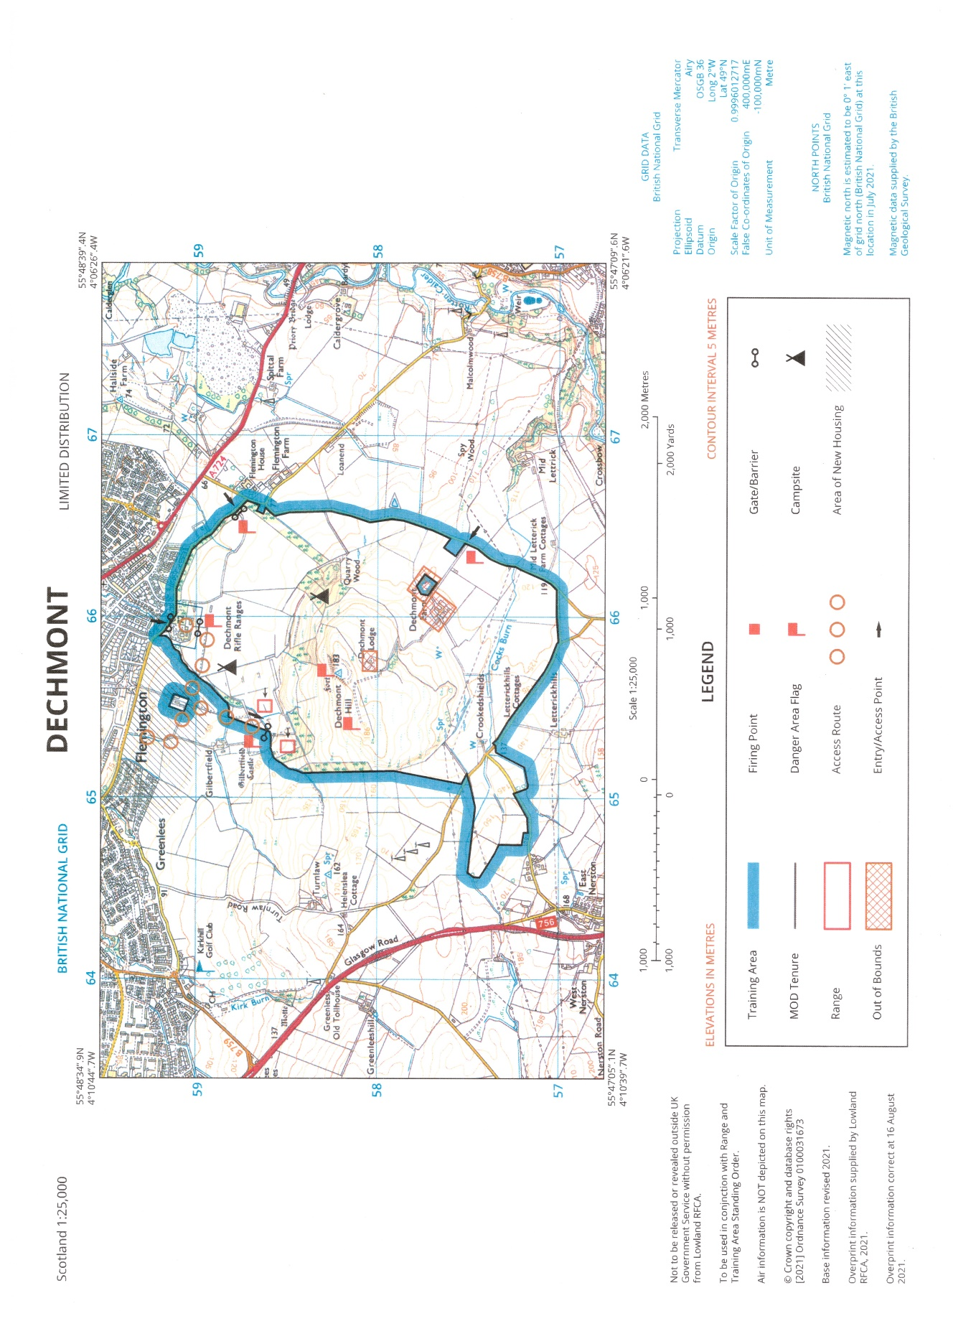
ANNEX A TO
DECHMONT RANGE STANDING ORDERS
DTD DEC 22

ANNEX A TO
DECHMONT RANGE STANDING ORDERS
DTD DEC 22

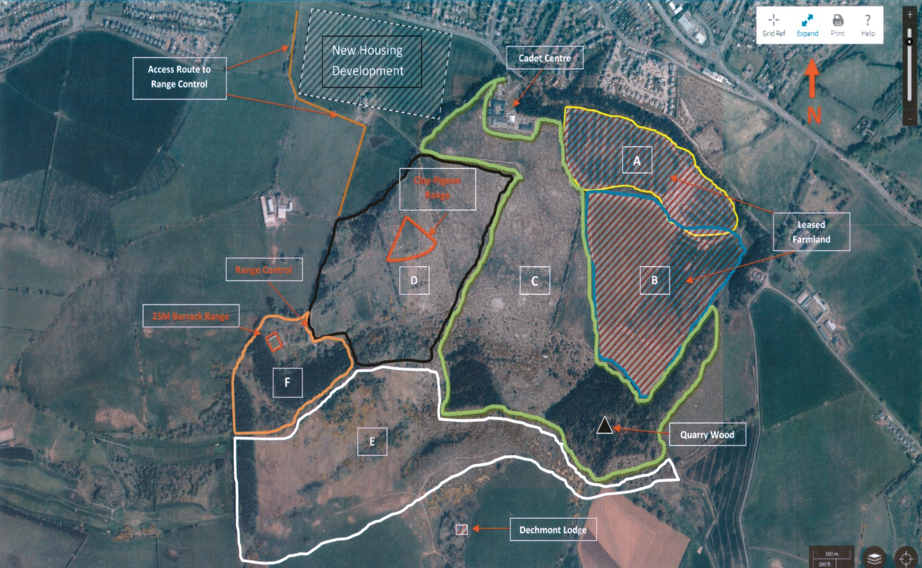

DECHMONT RANGE
GILBERTFIELD ROAD
CAMBUSLANG
G72 8YP
Visitors/Contractors 4C’s Brief
This 4Cs brief must be given to all visitors and contractors who wish to gain access to Dechmont Range and Training area.
Personal identification is required on site and must be produced if challenged by any members of the Range Staff.
This is a mandatory brief, and all guidance MUST be adhered to. Failure to comply with the guidance may lead to complications and delays on your next visit.

DECHMONT RANGE
ANNEX B TO
DECHMONT RANGE STANDING ORDERS
DTD DEC 22

The MOD 4Cs SYSTEM
A GUIDE FOR VISITING WORKERS AND CONTRACTORS
Your safety, health and wellbeing whilst working on this establishment is of key importance. This leaflet describes the arrangements to ensure your protection and the protection of those working around you. It applies equally to MOD staff and service personnel, as well as to all other visitors. Please take a few minutes of your time to read this through. If there are any questions it doesn’t answer, a list of contacts is given on the reverse to whom you may refer for further guidance.

What are the 4Cs?
MOD Establishments/LRFCA sites, due to the nature of activities undertaken, often present visitors with an unusual range of hazards. Many of these change on a daily basis. Equally, maintenance work and repair work can all introduce hazards of their own. Sometimes the two sets of activities can conflict. Effective safety management therefore relies on the following principles:
-That the work of different organisations is Coordinated.
-That different organisations Cooperate to ensure that work is carried out safely.
-That different organisations Communicate on safety matters.
-That, where there is a conflict of interest, that work is Controlled, to ensure respective tasks are carried out in a safe manner.
So how does it work?
The person who invited you to Dechmont Range is known as your Host. This may be an LRFCA member of staff, or a representative of one of the other organisations or contractors. They are responsible for notifying the 4Cs Duty Holder or Deputy of your arrival. The Host is also responsible for ensuring that your work is managed in a safe manner.
Step 1 – Arrival:
When you arrive, you will need to report to your Host who will in turn escort you to the 4Cs Duty Holder (or Deputy).
Step 2 – Report to Host:
The 4Cs Duty Holder (or Deputy) will give a general site briefing on the collective safety and security arrangements for the site fire evacuation procedure, speed limits, use of cameras and mobile phones etc. They will also discuss the detail of the job you have come to do and your intended method of working. They may also need to see your Risk Assessment. The 4Cs Duty Holder (or Deputy) will also tell you if a Permit to Work is needed for your work activity. You will also be asked to sign the visitors’ logbook.
Step 3 – Report to Area or Building Custodian:
Each building or area within Dechmont Range is under the control of an Area/Building Custodian. This may, or may not, be the same person as your Host. He or she is responsible for coordinating the day-to-day activity in any one area of Dechmont Range. They will advise you of any particular hazards in their area and let you know of any other activity taking place at the same time. They will also need to know what work you intend to carry out, to ensure that this does not conflict with any other local activity. Once this discussion has taken place, you will be able to commence work.

The 4Cs Process
Contractor / Worker arrives at Site

Step 1:
Report to 4Cs Duty Holder (or Deputy)

-Receive general site induction brief
-Book in at Reception Point (sign visitors book)
Step 2:
Reports to the 4Cs Duty Holder (or Deputy)

-Discuss detail of job and method of working.
-Exchange of known hazard information
(Communication).
-Review of Risk Assessment.
-Requirement for Permits to Work (Control).
Step 3:
Report to Area/Building Custodian

-Discuss detail of job and method of working
(Cooperation).
-Exchange information on particular site
hazards.
-Exchange information on other activity in the area (Coordination).
Proceed with Task

Step 4: On Completion
Notify Area/Building Custodian/Host

Book out at Reception Point, Sign out on Visitors’ Book

Site Rules
No alcohol or drugs may be brought onto Dechmont Range or Training Area.
Smoking is NOT permitted anywhere except designated areas.
All persons employed on this site must hold a valid establishment pass.
Escorts are required for entry into any of the following areas:
1. 25m Barrack Range
2. Workshop
3. Classroom
Permits to Work:
A Permit to Work MUST be obtained prior to carrying out any of the following activities:
Excavation, hot work, work on electrical systems, work on fuel installations, work on boilers or other pressure systems, work on a potential explosion site, work at height, work in any manhole or confined space. (Contact your Host for details).
Accidents and Incidents: In the event of any safety related accident or incident the site SHE Advisor is to be informed as soon as practicable.
Rules for vehicles:
Seat belts are to be worn at all times.
The speed limit around Dechmont Range Compound is 15mph.
Marching Troops ALWAYS have priority.
Mobile phones are not to be used whilst driving.
Parking is only permitted in designated areas. Reversing delivery vehicles must always have a guide.
Dechmont Site Contacts
0141 641 4898
FIRE or OTHER EMERGENCY: Ext 999
4C’s Duty Holder (Range Manager) 07764695185
4C’s Deputy (Range Warden) 07584210219
Site Admin Office 0141 641 4898
Site Health & Safety Advisor 07764695185
Frequently Asked Questions:
Q - I’m just a delivery driver / I just came here to attend a meeting. Do I need to go through all this?
Where your work is unlikely to have an impact on anyone else, the general site induction given at Step 1 may be sufficient. Your host will determine this.
Q - I’ve been in and out of this establishment for years. Surely, I don’t have to do this every time I come in?
Where workers carry out routine or regular and repetitive tasks, Steps 1 & 2 will be covered by a periodic briefing given by the Host. However, you will still need to report to the Area Custodian to exchange information on the day-to-day activity in the area in which you intend to work.
Q - I’ve been called in out-of-hours and neither the host nor the custodian are available. What should I do?
This situation arises when responding to a task that requires an urgent repair. You should only attempt to ‘make safe’ or carryout such restoration work as is within your competence and has been agreed with your Host. If they are not physically present on site, further advice should be sought, from the Host, by telephone.
ANNEX C TO
DECHMONT RANGE STANDING ORDERS
DTD DEC 22

ACCIDENT / INCIDENT IMMEDIATE ACTION AND REPORTING AIDE-MEMOIRE
01. ON THE COMMAND “STOP, STOP, STOP”
STOP ALL fire and movement and await further instructions from the safety staff.
02. GIVE FIRST AID AND GET MEDICAL HELP
If required implement the Medical Emergency Plan.
03. ENSURE WEAPON SAFETY AND PRESERVE EVIDENCE
Do not attempt to unload, make safe, strip or clean any weapon involved, (unless not doing it would increase the risk to personnel) or alter bearing, range or elevation setting (if necessary, move personnel to safety).

04. INFORM AND SEEK ADVICE

- Range control (RAU) – who will advise on contacting others.
- Exercise director and senior planning officer.
- ATO, Defence Accident and Investigation Branch (DAIB Ops) are always to be informed.

05. CORDON THE AREA AND GATHER EVIDENCE
- Protect evidence. Everything is to remain in situation until seen by investigators.
Personnel are to mark their position with a helmet or Personal Load Carrying Equipment (PLCE).
- Record weapon details. Damaged weapons, lodged bullets, empty cases are to be left where they fell. If necessary, seek Armourer assistance.
- Identify witnesses. To prevent influencing, stop discussion and separate witnesses.
Witnesses are to produce a brief written account of the events.
- Make a sketch map for the investigators. Record the position of all fragments and personnel (injured and witnesses), stating the direction they were facing, their stance, weapon state and the direction of their weapon.

06. CONTROL AMMUNITION AND EVIDENCE
- Record the ADAC, designation and Batch Key Indicator (BKI) of the ammunition; it must all be segregated and is not to be used again unless approved by ATO.
- Misfires/Blinds are to be destroyed in accordance with Pamphlet 21.
- Only after all investigating agencies have been consulted should the ATO authorise clearance of the scene.

07. SUSPENSION OF RANGE STAFF All Staff directly involved are temporarily suspended, pending investigation.
08. RECORD THE ACCIDENT/INCIDENT IN THE LAND RANGE LOG
This is the Conducting Officer’s responsibility.
09. FURTHER REPORTING REQUIREMENTS
What must be notified? ‘In short – everything!’
All incidents/Accidents are to be reported using DURALS or in accordance with Single Service Cadet Policy.
All accidents, incidents, near misses and unsafe acts must be notified. These are all now
encompassed in the terminology of ‘occurrence’, which forms a basic but essential shift in aligning Defence terminology within the four Commands (Royal Navy, Army, RAF, UKStratCom).

CONTACT DETAILS FOR DAIB:
Telephone: 01980 348622
E-mail: DSA-DAIB-Land-Mailbox@mod.gov.uk

ANNEX D TO
DECHMONT RANGE STANDING ORDERS
DTD DEC 22
MEDICAL EMERGENCY IMMEDIATE ACTION AIDE-MEMOIRE
01. STOP FIRING/FREEZE THE AREA –Stop all fire and movement and await instructions from the Safety Staff.

02. ADMINISTER FIRST AID - Implement the medical emergency plan.

03. EMERGENCIES WITH CASUALTIES Dial 999 Immediately and Inform Range Control with the following details:

a. Type and Number of Casualties
b. Location of casualties:
Dechmont Training Area Gilbertfield Road Cambuslang G72 8YP (provide exact location with a 6 figure grid reference).
c. RV for ambulance - advise on most suitable route and or send a guide to meet the ambulance at the RV point and guide it in.
d. Civilian telephone for Range Control: 0141 641 4898. Range Staff are available to assist in coordinating the ambulance to the appropriate RV.

04. NON-EMERGENCIES

a. Make casualty comfortable.
b. Administer first aid if required.
c. Make arrangement to transport casualty to the nearest A&E department at Hairmyres Hospital:

University Hospital Hairmyres
Eaglesham Road
East Kilbride
G75 8RG
Tel: 01355 585 000

05. Emergency RVs

The emergency RVs for Dechmont Training area are:

Range Control OS Grid Ref NS 6535, 5858
RV1 Gilbert Field Road (Amb Meet Point) OS Grid Ref NS 6535, 5937
RV2 Glasgow and Lanarkshire Cadet Centre OS Grid Ref NS 6595, 5915
RV3 Old Road OS Grid Ref NS 6660, 5879
RV 4 Dechmont Farm Access Road OS Grid Ref NS 6640, 5751

ANNEX E TO
DECHMONT RANGE STANDING ORDERS
DTD DEC 22
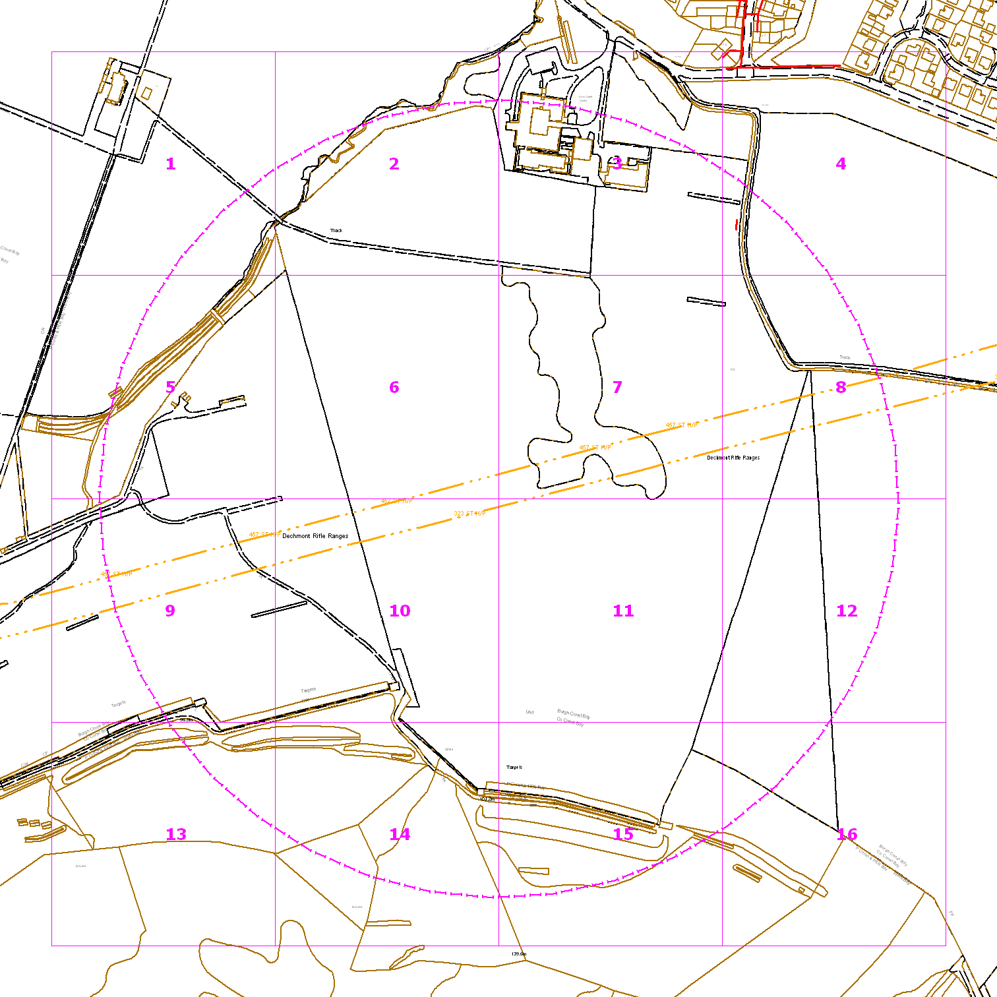
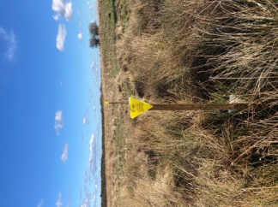

There are two high pressure gas pipelines that run through Dechmont Training Area. These pipelines are clearly marked by Scottish Gas Network (SGN) markers as shown in the images above.
The rules regarding training in the vicinity are listed below:
- Vehicle Movement: vehicles may only cross the pipelines at the recognised crossing point
- No digging within one metre of the pipeline
- No blank firing or pyrotechnics within three metres of the pipelines

SMELL GAS? CONTACT 0800 111 999 National Gas Emergency number
Link to the Scottish Gas Network SGN website.
https://www.sgn.co.uk/
https://www.sgn.co.uk/help-and-advice/digging-safely

ANNEX F TO
DECHMONT RANGE STANDING ORDERS
DTD DEC 22

LYME DISEASE AND LEPTOSPIROSIS
References:
A. JSP 371 Joint Services Manual on Pest Management 2005.
B. SGPL: 19/02 Communicable Disease Control in the Armed Forces dated 14 Nov 02.
C. NHS Inform website

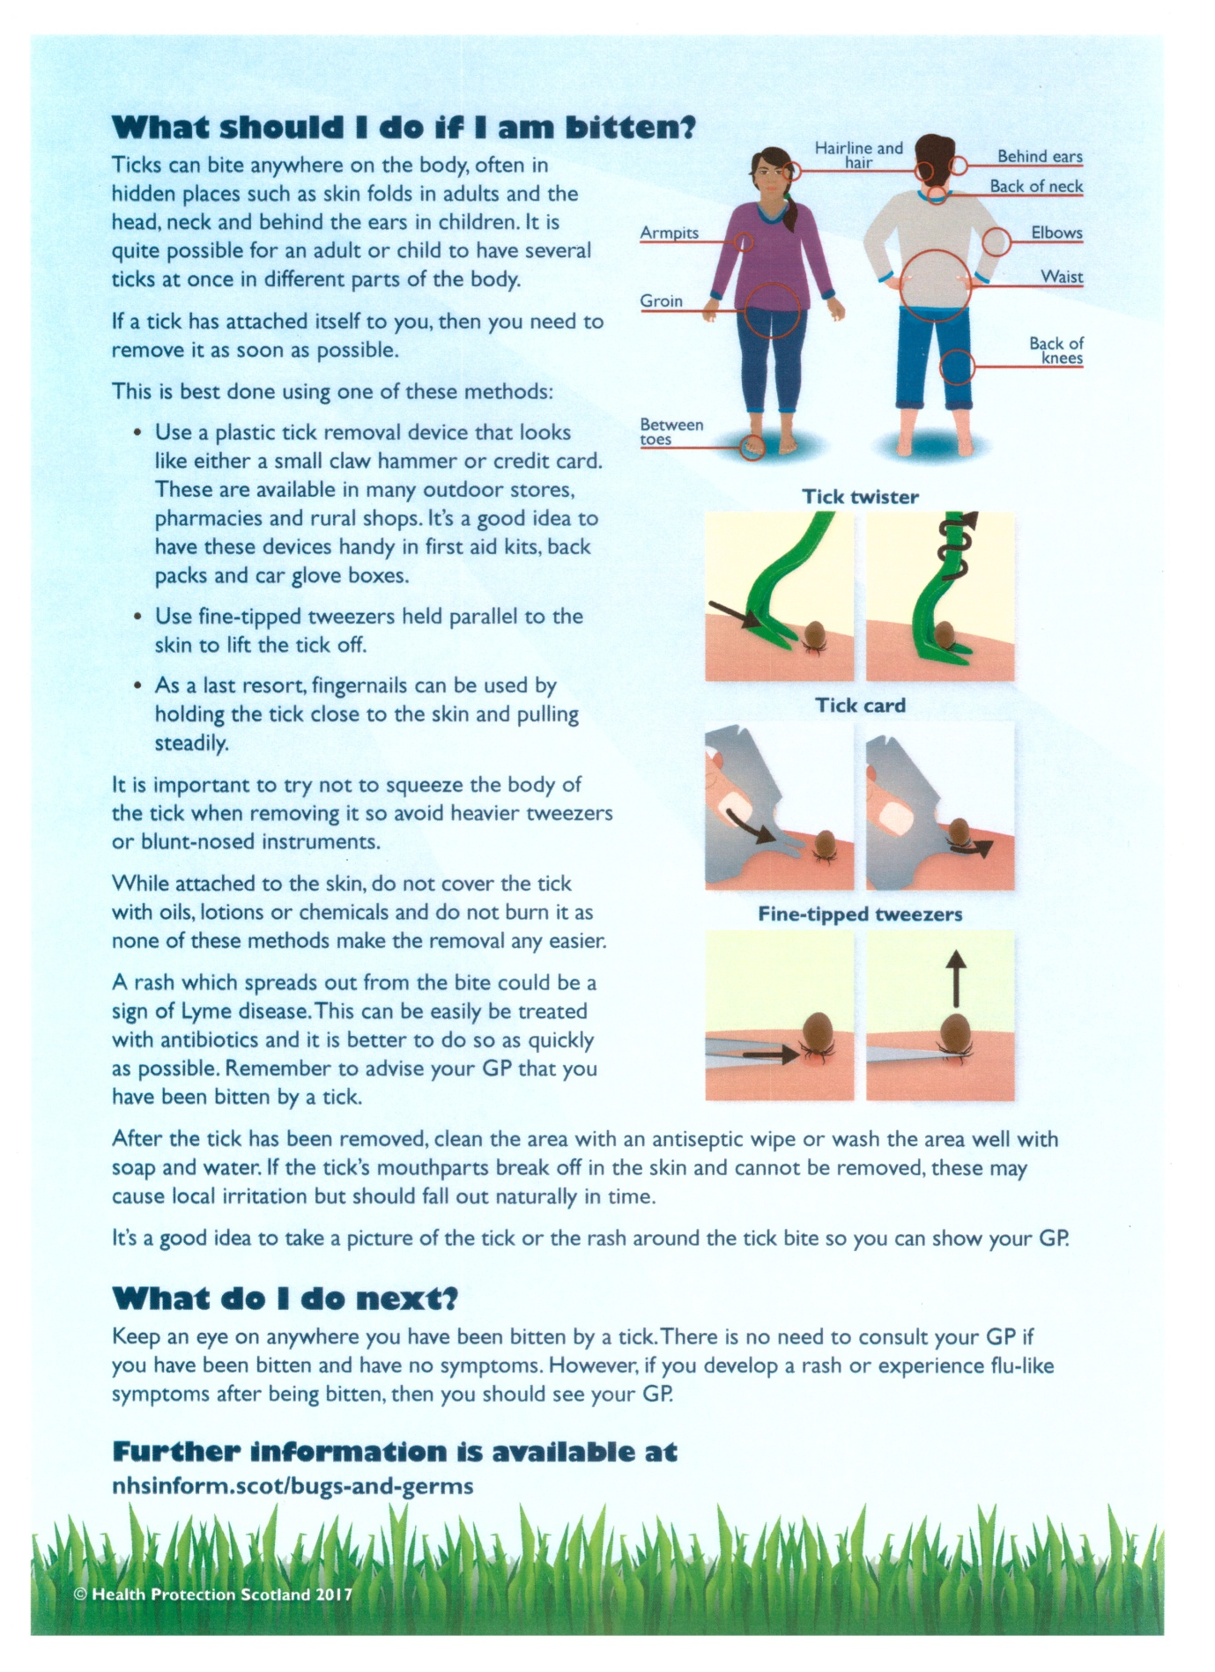
ANNEX G TO
DECHMONT RANGE STANDING ORDERS
DTD DEC 22
RADIATION SAFETY
01. Unit Radiation Safety Officer (RSO) is responsible for radiation safety matters for visiting units.
02. Visiting Units planning to use the Training Area Ranges are responsible for the safe use/storage/accounting of equipment with radioactive components. Where possible, appropriate storage facilities will be provided for such equipment by visiting Units.
03. User Units should be in possession of an up-to-date copy of JSP 392.
04. Clean up kits for use in event of breakage of a Betalight (also known as GTLS or Nuclear Lamp) are to be held by visiting units. Radiation warning signs for use outside temporary storage areas can be obtained from Range Control if required.
05. A Radiation Protection Supervisor (RPS) should be nominated from the visiting Unit, if it is planned to bring equipment with radioactive components onto the training areas. The RPS should be noted on your planning documents.
The RPS from the visiting Unit is to ensure that:
- All equipment containing radioactive materials are safely stored when not in use.
- Storage areas should be demarcated with a radiation warning trefoil, and the name and contact number of the Unit RPS.
- All radioactive material can be accounted for.
- All radioactive items are transported in accordance with the instructions contained in JSP 392.
- Ensure that all users of equipment containing radioactive material are aware of the hazards and given instruction as to the precautions to be observed.

06. In the case of Units using equipment capable of generating ionising radiation (e.g., X-ray sets radiography equipment etc.) on the camp, the Unit RPS is responsible for the radiation safety of that equipment. The Unit RPS is to:
- Be familiar with the dose rates and hazard distances associated with the equipment.
- Inform Unit RSO of the location of any Planned Controlled Areas.
- Establish and police any such Controlled Areas.
- Provide barriers, warning signs and lights etc.
- Administer dosimetry if required.

07. Similarly, in the case of Units using equipment capable of generating Class 3 LASEX and above, the unit should appoint a LASER RPS, who will be responsible for the safe use of that equipment. The RPS (Laser) is to:
- Be familiar with the hazard distances associated with the equipment.
- Inform Unit RSO of the location of any planned hazard areas.
- Ensure all personnel training with the equipment are familiar with the hazards and precautions.
- Prevent inadvertent access to the hazard area (by other persons on the range).
- Prevent any hazard arising outside the Exercise area.

08. Any radiological incident or occurrence is to be reported immediately to Unit RSO. Radiological incidents include fires involving radioactive material, loss of radioactive items, spills of radioactive material, damage to sealed sources, suspected over exposures, or ingestion of radioactive material.
09. Unit RSO is first to notify the Commanding Officer and other appropriate personnel (e.g., Fire Officer) of the incident, and is then to notify DRPS and the Army Health and Safety Focus (R02 Rad) at HQ Land Command; according to the procedures given in chapter 28 of JSP 392. External agencies (e.g., Environment Agency, Local Health and Safety Executive Inspector) are not to be contacted without prior notification of DRPS and R02 Rad.
10. An investigation into the incident is to be undertaken by the RPS from the visiting unit as soon as practicable, where appropriate with the assistance of the RPA, and the report distributed to the relevant MOD Authorities listed in JSP 392 Chapter 28.

Annex H to Dechmont Range Standing orders
 | Lowland RFCA Booking Form  Dechmont Training Area  Range Control  Range Manager |  |  | Bid No.  (Supplied By Range Manager) | Bid Date | Type of Trg | Start Date | End Date | No of Personnel
 |  |  |  |  | Click here to enter a date. | Choose an item. | Click here to enter a date. | Click here to enter a date.
Unit Requesting Booking |  |  | Unit Address |  |  |  |  |  | Post code
POC |  | Appointment |  | Telephone |  | Mobile |  | e-mail
Alt POC |  | Appointment |  | Telephone |  | Mobile |  | e-mail
Training Area/Range Required |  |  |  | Date from |  | Date To |  | Start Time | End time
Choose an item. |  |  |  | Click here to enter a date. |  | Click here to enter a date.
Choose an item. |  |  |  | Click here to enter a date. |  | Click here to enter a date.
Choose an item. |  |  |  | Click here to enter a date. |  | Click here to enter a date.
Choose an item. |  |  |  | Click here to enter a date. |  | Click here to enter a date.
Choose an item. |  |  |  | Click here to enter a date. |  | Click here to enter a date.
Choose an item. |  |  |  | Click here to enter a date. |  | Click here to enter a date.
Range Booking  Target Requirements |  | Qty | Vehicle type |  | Qty | Facility Required |  | Start date | End date
Choose an item. |  |  | Choose an item. |  |  | Choose an item. |  | Click here to enter a date. | Click here to enter a date.
Choose an item. |  |  | Choose an item. |  |  | Choose an item. |  | Click here to enter a date. | Click here to enter a date.
Choose an item. |  |  | Choose an item. |  |  | Choose an item. |  | Click here to enter a date. | Click here to enter a date.
Description of training (Give a brief Description of the training Objectives)
To Be Completed By Range staff
Supporting documentation received |  |  | Choose an item. | Date recd | Click here to enter a date. | Training requirements authorised |  |  | Choose an item.
Unit contacted |  |  | Choose an item. | Date sent | Click here to enter a date. | Range signature |  | Choose an item.
Confirmation by unit week prior to trg |  |  | Choose an item. | Handover of facilities post trg satisfactory |  |  |  | Choose an item.
Comments from Handover
Range Staff Signature |  |  |  |  |  |  |  | Date
Dechmont Training Area/ Live Firing Ranges Booking Process:
1. All completed Booking Forms are to be sent to the Range Manager or alternatively to Range Control
2. Bookings are to be submitted a minimum of 7 days prior to training start date, Bookings submitted less than 7 days must be confirmed by the Range Manager prior to commencing planning in order to ensure Range staff availability.
3. Cancellations must be confirmed at the earliest opportunity or at least a minimum of 48 hours before training was planned to start.
4. Key Contact Details:
Range Control Tel: 0141 641 4898
Range Manager - Kevin McAtee: 07764 695 185
Range Warden P/T - Derek Brow: 07584 210 219

RANGE STANDING ORDERS (RSOs) FOR THE 25M BARRACK RANGE
(DECHMONT BARRACK RANGE)
The most recent version of this chapter can be found in the Dechmont file library on the Lowland RFCA website.

DECHMONT TRAINING AREA CLAY PIGEON RANGE - STANDING ORDERS

IMPORTANT TELEPHONE NUMBERS
Range Control Landline: 0141 641 4898
Range Manager Mobile: 07764 695185
Range Warden P/T Mobile: 07584 210219
INTRODUCTION
1. The Clay Pigeon Range is a "Down the Line" Range. It is to be booked using the procedure in Dechmont Range and Training Area Standing Orders Chapter 1 Annex G. Safety Officers/RCO’s are to ensure a copy of the RSD/RA is sent to range control prior to firing commencing. Timings for the use of the range are set by Range Control. This will be confirmed on the booking form.
2. The minimum number of personnel required to be on the range before firing is authorised is four.
3. Only safety vehicles are permitted on range. All other vehicles are to be parked in designated areas.
4. Only shotguns, which are serviceable and properly licensed, are to be used. No other type of firearm is to be used on this range.
5...Only properly authorised clays and cartridges are to be used and any current restrictions are to be adhered to. No other targetry is to be used.
6. The minimum age to fire on this Clay Pigeon Range is 14 years old. Cadets can be 13 years of age, but they are always to be supervised on a one-to-one basis by a qualified adult.
QUALIFICATIONS REQUIRED TO CONDUCT LIVE FIRING
7. The qualifications listed below are the absolute minimum required to conduct live firing on this Range. These qualifications cover both military and civilian personnel including Cadets of all three Services: Sea Cadets, Army Cadet Force, Air Training Corps and the Combined Cadet Force.
8.- Safety Officers must have qualified through at least one of the following certificated shotgun courses run by:
a. Clay Pigeon Shooting Association (Qualified Safety Officer Course)
b. Services Clay Target Shooting Association (SCTSA)
c. The British Association for Shooting and Conservation (BASC)

d. UK Practical Shooting Association (UKPSA)

9. Personnel must only carry out shotgun practices in conjunction with their qualification held and must not deviate in any way.
NOTE: Other range qualifications held are not acceptable.
BEFORE USE OF CLAY PIGEON RANGE
10. The Range is to be prior booked in accordance with Dechmont Range and Training Area Standing Orders Chapter 1 Annex G. On the day of confirmed use, Safety Officers will report to Range Control and sign the Range Log. Proof may be sought from time to time to verify the qualification held.
11. The RSD, Range Aide Memoire (RAM) and a Risk Assessment must be documented and submitted to Range Control before any firing begins. Safety Officers are to have in their possession Annex C and D to this Document.
12. Adequate Medical/First-Aid equipment and qualified personnel must be in place before firing commences. Safety Officers are to ensure that a means of communication with Range Control is in place and tested before firing commences.
DURING USE OF CLAY PIGEON RANGE
13.- The Range in Use flag is to be flown at all times when the Range is in use. There is to be a physical check that all range warning signs are in place and are visible.
14. Only authorised practices (down the line and in accordance with safety officer qualifications) will be conducted. All personnel must wear hearing and eye protection. Firing is to take place from within the safety cage and all firing is to be within the safety arc. Clays are not to be released at a low height across the range.
15.- Cadets and children under 16 years of age are to be supervised on a one-to-one basis when firing. When double-barrelled shotguns are used by firers under 16, they must only be loaded with a single cartridge, not two.
16. -If visibility reduces to the point that the danger area cannot be assured, firing is to stop until safety can be restored. If instructed by Range Control to stop firing, make shotguns safe until authorised to continue firing by Range Control.
17. The range is not to be used for night firing.
18. Any incident or accident is to be reported immediately to Range Control. Military Units are to follow the procedure laid down in Annex C and D to this document.
19..-If an ambulance is required the RSO/first aider must dial 999 immediately and contact Range Control that they have done so.
AFTER USE OF CLAY PIGEON RANGE
20. Lower the Range in use flag and all warning signs.
21. -Remove all unbroken clays, empty cartridge shells, empty boxes/cartons and any litter from the range.
22. -Report to Range Control and sign the Range Log to certify that the range is clear.
23. Report any damage or issues with the range or range equipment, to Range Control.
SUMMARY
24. Range Safety Officers are to always ensure the safety of firers and any spectators.
25. Please leave the Clay Pigeon Range in a clean and tidy condition.
26. Suggestions to how the range might be improved are welcomed; please speak to the Dechmont Range Manager Lowland RFCA.

DECHMONT TRAINING AREA ARCHERY RANGE - STANDING ORDERS

IMPORTANT TELEPHONE NUMBERS
Range Control Landline: 0141 641 4898
Range Manager Mobile: 07764 695185
Range Warden P/T Mobile: 07584 210219
INTRODUCTION
1. The Archery Range is situated in the same area as the Clay Pigeon Range and only one of these activities will be booked. It is to be booked using the procedure in Dechmont Range and Training Area Standing Orders Chapter 1 Annex G. Timings for use of the range are set by the Range Control. This will be confirmed on the booking form.
2. The minimum number of personnel required to be on range before shooting is authorised is four.
3. Only safety vehicles are permitted on range. All other vehicles are to be parked in designated areas.
4. There must be clearly visible straight line on the ground called the shooting line. Archers must shoot their arrows only when standing astride this line. There is no access ahead of the shooting line while shooting is in progress.
5. Archers shoot at the target directly opposite their shooting position. There is a definite time slot for shooting and the archer may not raise the bow arm to shoot until the signal to start shooting is given. A stop shooting signal is then given to allow archers to access targets and collect arrows.
6. Shooting will be in one direction only – at the designated target. Archers should aim continuously toward their target when drawing their bow.
QUALIFICATIONS REQUIRED TO CONDUCT ARCHERY
7. Only Archery GB members (membership cards are carried by members) can conduct Archery on this Range. A Field Captain is to be designated at the start of each session (usually one of the most experienced archers) to give audible signals for shooting.
BEFORE USE OF ARCHERY RANGE
8. The Range is to be booked in accordance with Dechmont Range and Training Area Standing Orders Chapter 1 Annex G. On the day of confirmed use, the Archery Instructor will report to Range Control and will sign the Range Log. Proof may be sought from time to time to verify the qualifications held.
9. RSD, Range Aide Memoire (RAM) and a Risk Assessment must be documented and submitted to Range Control before any archery begins.
10. Adequate Medical/First-Aid equipment and qualified personnel must be in place before archery commences. Instructors are to ensure that a means of communication with Range Control is in place and tested before archery commences.
DURING USE OF ARCHERY RANGE
11. The Range in Use flags are to be flown at all times when the Range is in use. There is to be a physical check that all range warning signs are in place and are visible.
12. Only authorised practices in accordance with Archery GB will be conducted.
13. Cadets and children under 17 years of age are to be supervised on a one-to-one basis when on the range.
14. If visibility reduces to the point that the danger area cannot be assured, shooting is to stop until safety can be restored. If instructed by Range Control to stop archery at any time, this must be adhered to until authorised by Range Control to commence archery.
15. Any incident or accident is to be reported immediately to Range Control who can assist with the medical plan required. The Range Manager is responsible for reporting the Occurrence as per Annex C guidance.
16..-IF AN AMBULANCE IS REQUIRED FOR A LIFE-THREATENING SITUATION DIAL 999 IMMEDIATLY, then Inform Range Control who will assist as required.
AFTER USE OF ARCHERY RANGE
17. Lower Range in Use flags.
18.- Remove any litter from the range.
19.- Report to Range Control and sign the Range Log to certify that the range is clear.
20. Report any damage or issues with the range or range equipment, to Range Control.
POINTS TO NOTE
21. The Archery Field Captain is to always ensure the safety of archers and any spectators.
22. Please leave the Archery Range in a clean and tidy condition.
23. Suggestions as to how the range might be improved are welcomed. Please speak to the Dechmont RM.

CHAPTER RESERVED FOR OFF ROAD DRIVING

NAVIGATION TRAINING/ORIENTEERING

References:
a. Dechmont Training Area Standing Orders.
b. OS Landranger 1:50 000 Map sheet 64.
c. OS Explorer 1: 25 000 Map Sheet 342
d. St Andrews Orienteering Club Glasgow (STAG) Dechmont Range Map 1: 10 000
General
1. Dechmont Training Area offers users the ideal land and classroom facilities to conduct all aspects of navigation training during both day and night. It offers civilian and military orienteering clubs a great area to conduct training or stage competitions.
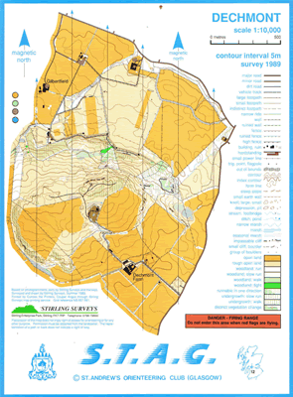
Dechmont Training area was the venue for the 1989 British Schools Orienteering Championships and has been used frequently by the South of Scotland Orienteering League (SOSOL).

2. The Byre Classroom offers users an indoor facility to conduct beginner lessons on the use of a map and compass before deploying onto the area to conduct practical navigation skills utilising the 627 acres of undulating land.
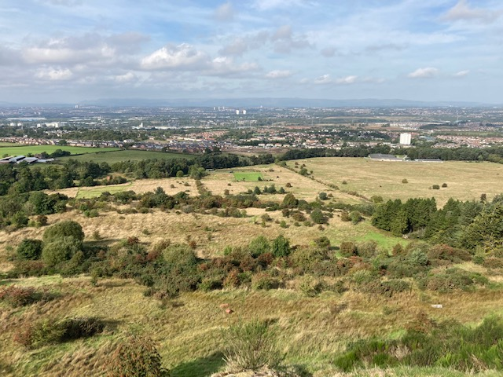
3. Dechmont Hill (Trig point 183m OS Grid Ref: NS 65688 58212) offers an excellent vantage point for map to ground and ground to map training offering extensive views over Cambuslang and out to the North.

4. Military booking for navigation facilities can be done Using Annex G to the Dechmont Training Area Standing Orders.
5. Civilian clubs wishing to use the facilities in this chapter can book them by contacting the Range Manager as per Annex G or alternatively by contacting the Lowland RFCA Alternative Venues’ contractor Denise Regan.

